H.T No
Regulations:
A18

Sreenidhi Institute of Science and Technology
(An Autonomous Institution)
Code No: 7K404 Date: 09-Aug-2023 (FN)

B.Tech II-Year II- Semester External Examination, Aug - 2023 (Supplementary)
MECHANICS OF MATERIALS (CIVIL)

Time: 3 Hours Max.Marks:70

Note: a) No additional answer sheets will be provided.
b) All sub-parts of a question must be answered at one place only, otherwise it will not be valued.
c) Missing data can be assumed suitably.

Bloom's Cognitive Levels of Learning (BCLL)

Remember | L1 | Apply | L3 | Evaluate | L5
Understand | L2 | Analyze | L4 | Create | L6

Part - A Max.Marks:20
Answer all QUESTIONS

 |  | BCLL | CO(s) | Marks
1 | A thin cylinder of diameter d is subjected to internal pressure p. Write down the expression for hoop stress and longitudinal stress. | L2 | CO1 | [2M]
2 | List any two applications of theories of failures. | L2 | CO2 | [2M]
3 | What is shear force and bending moment diagram? | L2 | CO3 | [2M]
4 | What is static indeterminacy? | L2 | CO4 | [2M]
5 | Define bending stress and bending moment. | L2 | CO5 | [2M]
6 | Define the terms : column and crippling load. | L2 | CO6 | [2M]
7 | What is hoop stress and explain why hoop stress is required. | L2 | CO1 | [2M]
8 | Draw the shear force diagram for a cantilever beam with a point end load W and length L. | L2 | CO3 | [2M]
9 | What is principle of superposition in beams? | L2 | CO5 | [2M]
10 | What is principle strain theory? | L2 | CO2 | [2M]
Part – B Max.Marks:50
ANSWER ANY FIVE QUESTIONS. EACH QUESTION CARRIES 10 MARKS.

 |  |  | BCLL | CO(s) | Marks
11. | a) | Derive an expression for circumferential stress and longitudinal stress for a thin cylinder subjected to an internal pressure P. | L4 | CO1 | [5M]
 | b) | Differentiate between thin and thick cylinders. | L3 | CO1 | [5M]
12. | a) | Explain in detail about Maximum shear stress theory. | L3 | CO2 | [5M]
 | b) | Explain in detail about Maximum principal stress theory. | L3 | CO2 | [5M]
13. | a) | The internal and external diameters of a thick cylinder are 300mm and 500mm respectively. It is subjected to an external pressure of 4 N/mm². Find the internal pressure that can be applied if the permissible stress in cylinder is limited to 13 N/mm². Sketch the variation of hoop stress and radial stress across the thickness of the cylinder. | L4 | CO3 | [5M]
 | b) | At a point in a loaded elastic member, there are normal stresses of 60 MPa and 40 MPa, (both tensile) at right angles to each other with positive scaring stress of 20 M Pa. Draw the Mohr’s circle diagram and find  (i) Principal stresses and their planes  (ii) Maximum shear stress and its plane. | L4 | CO3 | [5M]
14. |  | Determine the forces in all the members of the truss as shown in the fig.  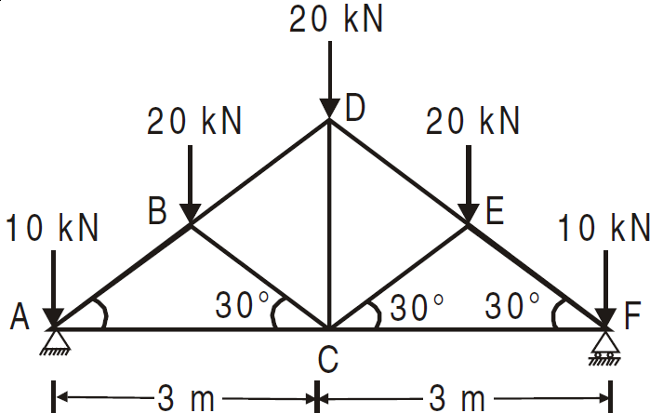 | L4 | CO4 | [10M]
 |  |  |  | CO4 | [5M]
15. | a) | Determine the buckling load for a stmt of tee section, the flange width being 100mm, over all depth 80mm and both flange and stem 10mm thick. The strut is 3m long and is hinged at both ends. Take E = 200 GN/m². | L5 | CO5 | [5M]
 | b) | A cantilever of length 1m carries a point load of 2000N at the free end. The cross section of the cantilever is an unequal angle of dimensions100mm by60mm and 10mm thick. The small leg of angle i. e 60mm is horizontal. The load passing through the centriod of the cross section. Determine the position of neutral axis and magnitude of maximum stress set up, at the fixed section of cantilever? | L4 | CO5 | [5M]
16. |  | A rolled steel joist ISMB 300 is to be used a column of 3 meters length with both ends fixed. Find the safe axial load on the column. Take factor of safety 3, fc = 320 N/mm² and a = 1/7500 . Properties of the column section. Area = 5626 mm², I XX = 8.603 x 10⁷ mm⁴ Iyy =4.539 x 10⁷ mm⁴ | L4 | CO6 | [10M]
17. | a) | What is effective length? Determine the effective length for all end conditions of a column? | L2 | CO1 | [4M]
 | b) | Define principal stress and strain. | L1 | CO2 | [3M]
 | c) | Derive the torsion equation? | L3 | CO3 | [3M]
18. | a) | Explain in detail about force deformation relationships of deformable bodies | L3 | CO4 | [4M]
 | b) | What is the ratio of torsional moments of resistance of a solid circular shaft of diameter D to that of a hallow shaft with external diameter D and internal diameter ‘d’? | L4 | CO5 | [3M]
 | c) | What are the assumptions made in Euler’s Theory. | L3 | CO6 | [3M]

-- 00 -- 00 –

